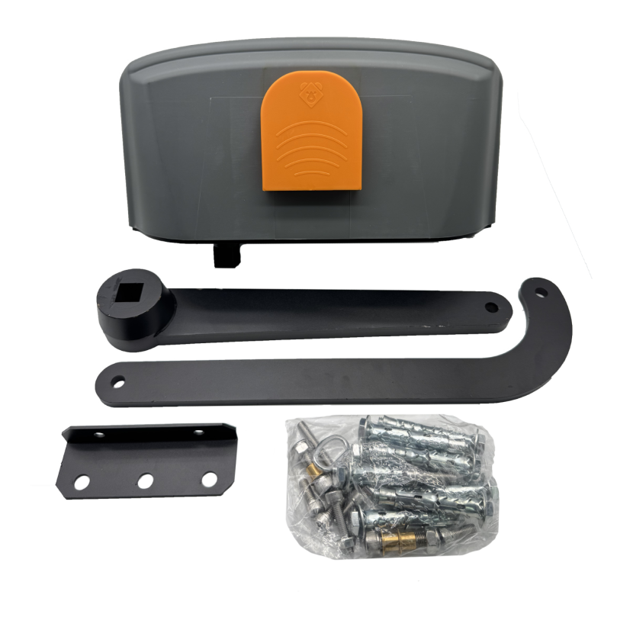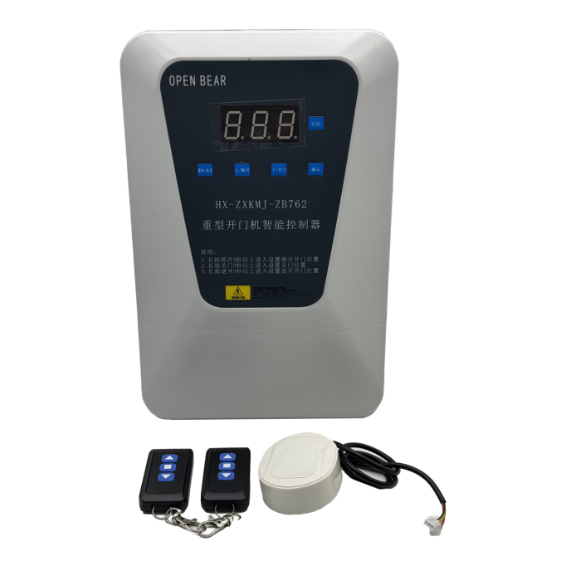
Specification of heavy-duty swing door operator
Item | Parameter | Remark
Working voltage | 220VAC±15% 50Hz
Motor operating voltage | 24VDC
Power of motor | 400W
Rated current | 20A
Rated Rotational speed | 3000rpm
Maximum output torque | 650Nm
Angular speed | 24°/s
Maximum opening Angle | ±90°
Maximum length of door leaf | 6m (single door)
Maximum weight of door leaf | ≤1200Kg
Thermal protection on motor winding | F Class 155℃
Operating frequency | Continuous running below 70℃
Operating ambient temperature | -35-70℃
Working environment | Indoor or sheltered outdoor environments
Running noise | ≤65dB
Temperature rise | ≤15℃
Weight of main unit packaging | 19.1Kg
Weight of controller packaging | 3Kg
Body size (length * width * thickness) | 510*305*255mm
Packing size | 385*375*160mm

